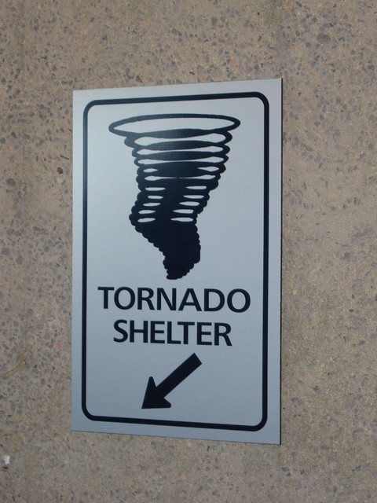

TORNADO/
STORM SHELTER POLICY

The City of LeRoy has installed a new light outside the door of the tornado shelter (southeast corner of Community Building). When the National Weather Service puts the City of LeRoy in a Tornado Watch the light will turn to RED and the shelter will be unlocked. Same goes for an immediate Tornado Warning, the building will be unlocked and light will be ON. We ask that you stay in the shelter room and DO NOT wonder the rest of the community building, the restrooms will be available if needed.
**Cameras have been installed in the shelter room and the rest of the community building so that City employees are not required to be present. This is for the City’s protection as well as your own.
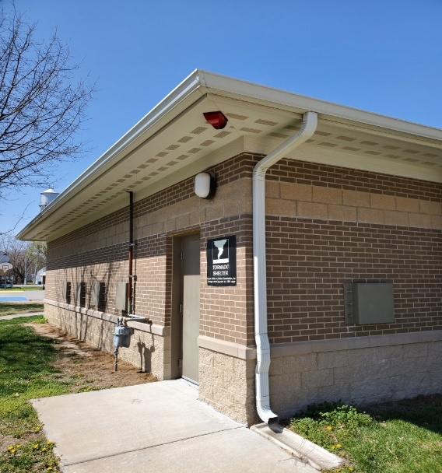
Any questions or concerns please call City Hall at 620-964-2245

